**Smart Stick for Blind People**

**Ms.Sakshi D.Rajmane1, Ms.Sujata A.Rathod 2, Ms.Sayali T.Mane3*, Ms.Shivanjali S.Boyane4, Ms.fija P.Shaikh5 and Mr.P.P.Chilme6***

Student, Department of Computer Engineering 1,2,3,4,5

Lecturer, Department of Computer Engineering6

Government Residential Women’s Polytechnic, Latur, India

**Abstract**: The project "Smart Stick for Blind People" is made to help visually impaired people walk safely and confidently. This project describes ultrasonic blind walking stick with the use of Arduino. according to who, 30 million peoples are permanently blind and 285 billion peoples with vision impairment. if you notice them, you can very well know about it they can’t walk without the help of other. one has to ask guidance to reach their destination. they have to face more struggles in their life daily life. using this blind stick, a person can walk more confidently

**I. Introduction**

The aim of this project is to design and develop a smart walking stick that helps visually impaired people detect obstacles from a distance using sensors and alerts them through vibrations or sound. This smart stick will improve their mobility, safety, and independence in daily life

**II. LITERATURE REVIEW**

Various assistive technologies have emerged in recent years, including sensor-based sticks and GPS-enabled systems. However, these often suffer from high costs and complexity. Our system is inspired by previous low-cost sensor projects, focusing on simplicity, effectiveness, and user-friendliness. Prior works emphasized obstacle detection, but often lacked customization and upgrade options. This paper builds upon those foundations by proposing a modular, open-source solution.

**III. METHODOLOGY**

* The smart stick is built using an Arduino Uno microcontroller, programmed via the Arduino IDE in C/C++. It processes input from an HC-SR04 ultrasonic sensor, which detects obstacles within a range of 2 to 400 cm. When an object is detected, the system activates a buzzer or vibration motor to alert the user.
* The stick is powered by a 9V battery for portability and ease of use. Its frame is made from lightweight piping, making it suitable for both indoor and outdoor environments.
* The design is modular, allowing future upgrades such as GPS navigation, voice alerts, and water detection to enhance the device's functionality and support.

**IV. SYSTEM DESIGN / ARCHITECTURE**

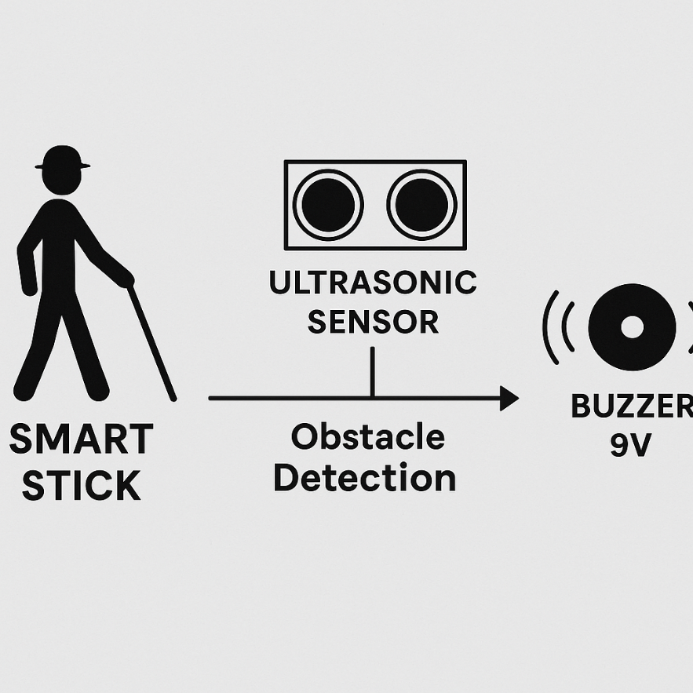

**V. IMPLEMENTATION**

1. **Ultrasonic Obstacle Detection:**

The Arduino Uno reads data from ultrasonic sensors (HC-SR04) to detect nearby obstacles. It calculates the distance by measuring the time taken for ultrasonic waves to reflect back from an object. If the object is within a certain range (e.g., less than 1 meter), alerts are triggered.

1. **Vibration and Sound Alerts:**

A buzzer and vibration motor are used to alert the user of nearby obstacles. The closer the object, the stronger or more frequent the alerts. This dual feedback system ensures the user gets notified even in noisy environments.

1. **Microcontroller Control (Arduino):**

The Arduino Uno serves as the brain of the system. It collects sensor data, processes distance calculations, and activates alerts. The program logic is written using the Arduino IDE.

1. **Power Supply:**

A 9V battery or rechargeable Li-ion battery is used to power the system. A power switch is added for user control, making it easy to turn the stick on and off as needed.

1. **Stick Design & Mounting:**

All components are securely mounted on a standard walking stick. The ultrasonic sensor is fixed at the top-front to scan the user’s walking path, while other components are placed to maintain balance and ease of use.

**VI. RESULT AND ANALYSIS**

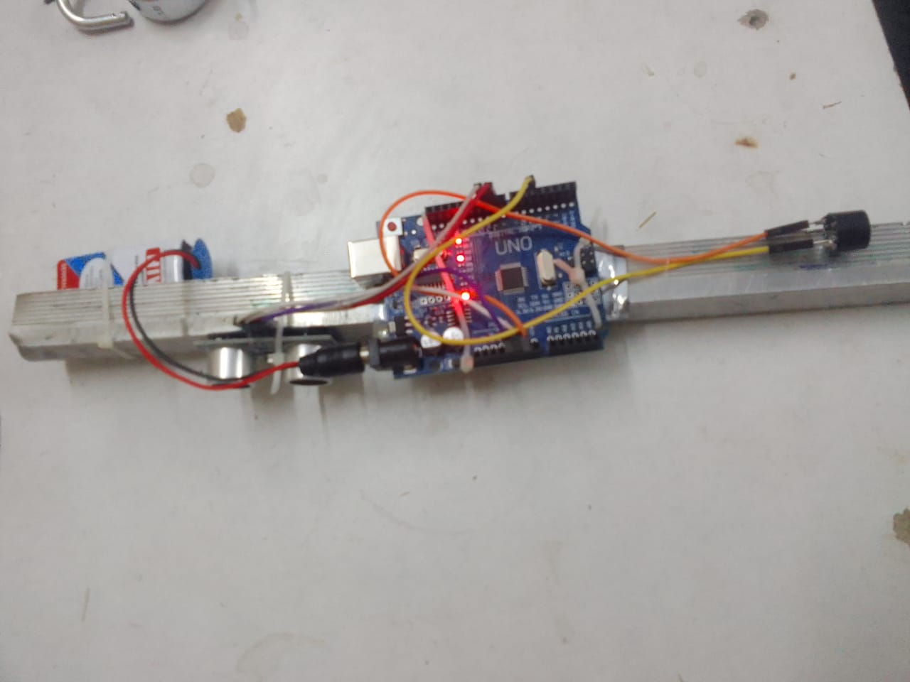

s

**VII. Future Scope**

* The Smart Stick for Blind People can be improved by adding GPS and voice navigation to help users reach destinations independently. Voice assistance using text-to-speech can give real-time obstacle warnings and directions, making the device more user-friendly.
* AI and camera integration could enable the stick to recognize specific obstacles

**VIII. Discussion**

The Smart Stick for Blind People successfully demonstrates how simple, low-cost technology can make a meaningful impact on the lives of visually impaired individuals. By combining an Arduino with ultrasonic sensors, buzzers, and vibration motors, the device provides real-time alerts about nearby obstacles, enhancing the user's awareness of their environment. The dual feedback system—sound and vibration—ensures that the user receives alerts even in noisy surroundings, making the stick more reliable in different situations.

However, the current design has some limitations. It primarily detects obstacles in front and may miss those at higher or lower levels, such as hanging objects or ground holes. Additionally, while the system is effective for short-range detection, it lacks features like GPS, voice commands, or emergency communication, which would significantly increase its usefulness. Despite these limitations, the project lays a strong foundation for future improvements and showcases the potential of assistive technologies in promoting independence and safety.

**IX..CONCLUSION**

The Smart Stick for Blind People provides an effective solution for visually impaired individuals to navigate safely using ultrasonic sensors, buzzers, and vibration motors for real-time obstacle detection. While it shows promising results, future enhancements like GPS navigation, voice assistance, and wireless connectivity could greatly improve its functionality. Despite current limitations, the project lays a solid foundation for advancing assistive technology, offering increased independence and safety for visually impaired users.

**V. ACKNOWLEDGMENT**

We would like to express our sincere gratitude to all those who supported us throughout the development of this project, *“Smart Walking Stick for the Visually Impaired.”*

First and foremost, we thank our project guide Mr.P.C.Chilme , for their invaluable guidance, encouragement, and constructive feedback at every stage. Their expertise and insights greatly enriched our work.

We also extend our thanks to Government Residential Women’s Polytechnic Latur for providing the necessary resources and a conducive environment for carrying out this project.

**REFERENCES**

[1] Metev, S.M., Veiko, V.P., *Laser Assisted Microtechnology*, Springer, 1998.  
[2] Breckling, J., *Analysis of Directional Time Series*, Springer, 1989.  
[3] Zhang, S., et al., "Ultrathin TFTs," *IEEE Electron Device Letters*, 1999.  
[4] Wegmuller, M., et al., "Fiber Measurements with OFDR," *Proc. ECOC*, 2000.  
[5] Sorace, R.E., et al., “Digital-to-RF Converter,” U.S. Patent, 1997.